

JOURNAL OF APPLIED LEARNING AND TEACHING
Book Review Template

Heading and reviewer. Author(s), Book Review of Title in full, Year of publication, Place, Publisher, date of publication, edition (where applicable). Followed by name of reviewer(s), designation(s) and institutional affiliation(s).
For example:
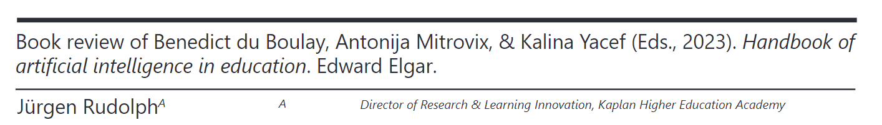

Author(s) Detail(s) Please repeat this step if there is more than one author.

Author 1
First Name: Middle Name: Last Name: Designation/Title: Affiliated Institution/Organisation:

For example:

ORCID no. for all authors:

Article Content
Word count: 1,000 – 2,000 words (indicative).

Please include a picture of the book cover.
For example:
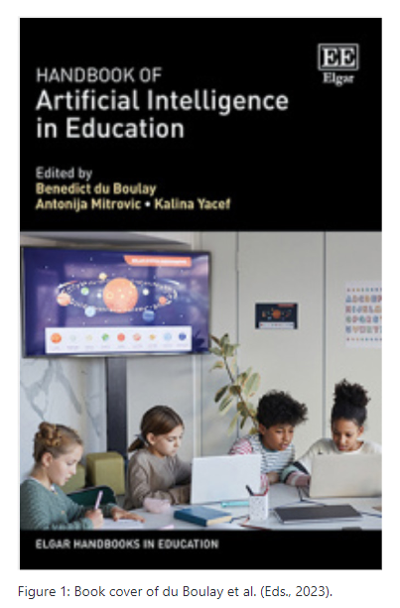
The following suggested structure is not cast in stone.
Introduction. The review should begin with an introduction to the topic and an overview of the content of the book. What is your main point in presenting this review? Describe the background and qualifications of the author. Who is the author’s intended audience? What is the author’s aim? What is the author’s main thesis?
Organisation / structure & findings. What is the organisation / structure of the book? What are the main findings and conclusions? How accurate and current is the information presented? How well does the development of the author’s thesis book draw on supporting ideas, arguments, documentation, and/or evidence? Does the evidence support the conclusions?
Critical evaluation. How current is the information presented? How effective is the author’s method of developing the information? What is your assessment of the book’s strengths and weaknesses? How does it compare with comparable works? Does the book make a meaningful contribution to the literature? What are your overall comments and conclusions about the book? Why or why not would you recommend the book to others? What is your overall assessment of the book?
Citations and word count. When quoting from the book, add the page number in brackets immediately following the quote. The word count would normally be between 1,000 – 2,000 words, but longer reviews will also be considered.

Use of illustrations
If pictures/diagrams are included as part of your book review, please place them at the end of a paragraph before commencing with a new paragraph.

For example:

