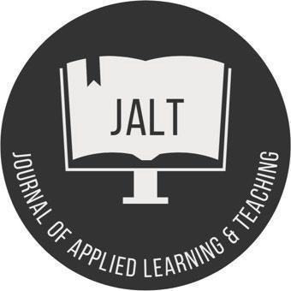

JOURNAL OF APPLIED LEARNING AND TEACHING
Interview Template

Article Details
Article Title:
Keywords (At least 5 separated by a semi-comma):

Author(s) Details Please repeat this step if there is more than one author.

Author 1
First Name: Middle Name: Last Name: Designation/Title: Affiliated Institution/Organisation:

For example:

Correspondence:
Email Address:

ORCID no. for all authors:

Article Content
Word count: 3,000 – 8,000 words (indicative).

Abstract
Please limit your abstract to around 200 words.

Keywords (alphabetical order)
At least five, separated by a semi-comma.

Contents

Content and structure will vary.

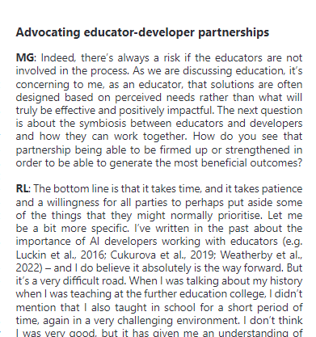

The inclusion of photos and pull-out quotes is encouraged.

Acknowledgements (optional)

Use of illustrations, figures and tables
If pictures/diagrams are included as part of your article, please place them at the end of a paragraph before commencing with a new paragraph.
For example:

