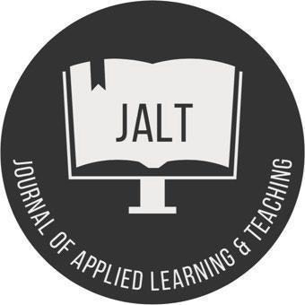

JOURNAL OF APPLIED LEARNING AND TEACHING
Research Article Template

Article Details
Article Title:
Keywords (At least 5 separated by a semi-comma):

Author Detail(s) Please repeat this step if there is more than one author.
Author 1
First Name: Middle Name: Last Name: Designation/Title:
Affiliated Institution/Organisation:

For example:

Correspondence:
Email Address:

ORCID no. for all authors:

Article Content
Word count: 3,000 – 8,000 words (indicative).

Abstract
Please limit your abstract to around 200 words.

Keywords (alphabetical order)
At least five, separated by a semi-comma.

Contents
The following suggested structure is not cast in stone but would normally be adhered to (with variations) for articles based on empirical research. JALT is also open to conceptual papers.

Introduction. Present purposes of the study, research issues or problems and provide background for your work.

Literature review & theoretical framework. Present explicit international connections for relevant ideas and explain the theoretical underpinnings and key concepts of your paper, outlining linkages to relevant scholarly work in your field of research.

Methodology (conceptual papers would not have this section). Provide sufficient detail to allow the context of the work to be thoroughly understood and/or for the work to be reproduced. Provide sufficient detail for readers to understand how you engaged in your inquiry. Clear descriptions of your context and participants along with strategies used to collect and analyse data should be described. Ethical aspects also require discussion.

Analysis and Discussion (conceptual papers would not have this section). Results should be clear and concise.
Data analysis: data are presented according to the methodological framework adopted in the previous section and the author presents the results of the research based on the outlined methodology.

Discussion: data are discussed critically in accordance with the theoretical framework adopted initially and relevant literature with the aim to show how the research advances the field.
Conclusions and recommendations: This section should explore the significance of the results of the work, not repeat them. Combining your results and discussion into a single section may be suitable. Returning to relevant literature from the introduction should show how your work connects with or interrupts already published literature.

Acknowledgements (optional)

Use of illustrations, figures and tables
If pictures/diagrams are included as part of your article, please place them at the end of a paragraph before commencing with a new paragraph.
For example:

